Macaca Data Summary 2023

2023-11-13

資料統整

### Part 1 最初的資料

說明：收到的資料，尚未刪減任何資料。   
 - 包括有回報因故無法調查的樣區。

各林管處的調查人員人數

|  | 2020 | | 2021 | | 2022 | | 2023 | |
| --- | --- | --- | --- | --- | --- | --- | --- | --- |
| 林管處 | 樣區數 | 調查者人數 | 樣區數 | 調查者人數 | 樣區數 | 調查者人數 | 樣區數 | 調查者人數 |
| 宜蘭 | 42 | 38 | 42 | 42 | 42 | 41 | 42 | 42 |
| 新竹 | 55 | 48 | 55 | 52 | 55 | 57 | 55 | 54 |
| 臺中 | 50 | 54 | 50 | 59 | 50 | 58 | 50 | 58 |
| 南投 | 45 | 43 | 45 | 44 | 45 | 44 | 45 | 50 |
| 嘉義 | 52 | 45 | 52 | 43 | 52 | 43 | 52 | 44 |
| 屏東 | 47 | 44 | 48 | 46 | 48 | 52 | 48 | 50 |
| 花蓮 | 44 | 40 | 43 | 39 | 43 | 48 | 43 | 58 |
| 臺東 | 50 | 51 | 50 | 53 | 50 | 58 | 50 | 60 |
| Total | 385 | 363 | 385 | 378 | 385 | 401 | 385 | 415 |

今年沒調查的樣區列表

### Part 2 刪疏失的資料

刪除項目：  
1. 同一旅次超過7日才完成調查：同一旅次同一樣區內超過7日才完成調查，整個旅次的資料放棄。  
2. 開始時間晚於10點54分。  
3. 調查未滿6分鐘刪。  
4. 不在預設樣點上：容許GPS誤差在50 m，調查位置座標離預設樣點距離>50m刪除。

整體的樣點次流變

| variable | 2020 | 2021 | 2022 | 2023 |
| --- | --- | --- | --- | --- |
| 1 收到 | 4,842 | 4,868 | 4,837 | 4,831 |
| 2 檢核後 | 3,996 | 4,440 | 4,567 | 4,600 |
| 2-1 不足6分鐘 | 163 | 82 | 40 | 32 |
| 2-2 晚於11時才完成調查 | 518 | 152 | 73 | 122 |
| 2-3 超過7日 | 13 | 19 | 0 | 0 |
| 2-4 位置錯誤 | 214 | 177 | 119 | 73 |
| 2-5 3~6月以外 | 17 | 35 | 18 | 13 |
| 3 刪掉低於50m(3~6月、<50m、所有棲地類型) | 3,977 | 4,413 | 4,533 | 4,566 |
| 4 篩選後(3~6月、=>50m、only森林) | 3,856 | 4,272 | 4,377 | 4,419 |

樣區樣點的統計資料

|  | 第1旅次 | | | 第2旅次 | | |
| --- | --- | --- | --- | --- | --- | --- |
| 林管處 | 樣點 | 無疏失的樣點 | 正確率% | 樣點 | 無疏失的樣點 | 正確率% |
| 宜蘭 | 271 | 256 | 94.5 | 271 | 249 | 91.9 |
| 新竹 | 348 | 323 | 92.8 | 348 | 327 | 94.0 |
| 臺中 | 315 | 314 | 99.7 | 315 | 298 | 94.6 |
| 南投 | 308 | 293 | 95.1 | 263 | 237 | 90.1 |
| 嘉義 | 312 | 294 | 94.2 | 312 | 286 | 91.7 |
| 屏東 | 294 | 271 | 92.2 | 288 | 267 | 92.7 |
| 花蓮 | 275 | 267 | 97.1 | 275 | 265 | 96.4 |
| 臺東 | 321 | 313 | 97.5 | 321 | 307 | 95.6 |
| Total | 2,444 | 2,334 | 95.5 | 2,387 | 2,266 | 94.9 |

|  | 2023 | | |
| --- | --- | --- | --- |
| 林管處 | 樣點 | 無疏失的樣點 | 正確率% |
| 臺中 | 630 | 623 | 98.9(1.8) |
| 花蓮 | 547 | 531 | 97.1(0.4) |
| 新竹 | 696 | 672 | 96.6(3.2) |
| 臺東 | 642 | 613 | 95.5(-1.1) |
| 嘉義 | 624 | 585 | 93.8(0.9) |
| 屏東 | 584 | 546 | 93.5(1.1) |
| 南投 | 564 | 527 | 93.4(0.6) |
| 宜蘭 | 544 | 503 | 92.5(-0.7) |
| Total | 4,831 | 4,600 | 95.2(0.8) |

2023年各林管處各疏失資料類型的筆數

| Office | Survey | 樣點數 | 超過7日 | 晚於11時 | 不足6分鐘 | 誤差超過50m | 不在3~6月內 |
| --- | --- | --- | --- | --- | --- | --- | --- |
| 宜蘭 | 1 | 272 | - | 11 | - | 5 | - |
| 宜蘭 | 2 | 272 | - | 23 | 1 | 3 | - |
| 新竹 | 1 | 348 | - | 1 | - | 11 | - |
| 新竹 | 2 | 348 | - | 1 | - | 11 | - |
| 臺中 | 1 | 315 | - | 4 | - | 2 | - |
| 臺中 | 2 | 315 | - | - | 1 | 1 | - |
| 南投 | 1 | 308 | - | 11 | 4 | 4 | - |
| 南投 | 2 | 256 | - | 5 | 3 | 3 | 7 |
| 嘉義 | 1 | 312 | - | 7 | 7 | 6 | - |
| 嘉義 | 2 | 312 | - | 6 | - | 8 | 6 |
| 屏東 | 1 | 295 | - | 16 | 1 | 4 | - |
| 屏東 | 2 | 289 | - | 13 | 1 | 4 | - |
| 花蓮 | 1 | 273 | - | 7 | 4 | 1 | - |
| 花蓮 | 2 | 274 | - | 1 | 2 | 1 | - |
| 臺東 | 1 | 321 | - | 1 | - | 6 | - |
| 臺東 | 2 | 321 | - | 15 | 8 | 3 | - |
| Total | 1 | 2444 | - | 58 | 16 | 39 | - |
| Total | 2 | 2387 | - | 64 | 16 | 34 | 13 |

|  | 2022 | | | | | 2023 | | | | |
| --- | --- | --- | --- | --- | --- | --- | --- | --- | --- | --- |
| 林管處 | 超過7日 | 晚於11時 | 不足6分鐘 | 誤差超過50m | 不在3~6月內 | 超過7日 | 晚於11時 | 不足6分鐘 | 誤差超過50m | 不在3~6月內 |
| 宜蘭 | - | 6 | 6 | 15 | - | - | 34 | 1 | 8 | - |
| 新竹 | - | 18 | 2 | 18 | - | - | 2 | - | 22 | - |
| 臺中 | - | 1 | 1 | 4 | 12 | - | 4 | 1 | 3 | - |
| 南投 | - | 7 | 13 | 17 | - | - | 16 | 7 | 7 | 7 |
| 嘉義 | - | 15 | 3 | 21 | 6 | - | 13 | 7 | 14 | 6 |
| 屏東 | - | 10 | 9 | 23 | - | - | 29 | 2 | 8 | - |
| 花蓮 | - | 2 | 4 | 13 | - | - | 8 | 6 | 2 | - |
| 臺東 | - | 14 | 2 | 8 | - | - | 16 | 8 | 9 | - |
| Total | - | 73 | 40 | 119 | 18 | - | 122 | 32 | 73 | 13 |

篩選後的資料後，各林管處的獼猴調查統計

| Office | Survey | 樣點數 | 孤猴 | 猴群 |
| --- | --- | --- | --- | --- |
| 宜蘭 | 1 | 251 | 4 | 10 |
| 宜蘭 | 2 | 241 | 3 | 5 |
| 新竹 | 1 | 332 | 0 | 4 |
| 新竹 | 2 | 332 | 0 | 6 |
| 臺中 | 1 | 301 | 0 | 12 |
| 臺中 | 2 | 303 | 0 | 9 |
| 南投 | 1 | 272 | 3 | 15 |
| 南投 | 2 | 225 | 0 | 13 |
| 嘉義 | 1 | 282 | 3 | 22 |
| 嘉義 | 2 | 283 | 1 | 16 |
| 屏東 | 1 | 259 | 7 | 16 |
| 屏東 | 2 | 254 | 3 | 23 |
| 花蓮 | 1 | 239 | 1 | 10 |
| 花蓮 | 2 | 246 | 1 | 10 |
| 臺東 | 1 | 306 | 7 | 44 |
| 臺東 | 2 | 293 | 7 | 19 |
| Total | 1 | 2,242 | 25 | 133 |
| Total | 2 | 2,177 | 15 | 101 |

### Part 3 納入分析的資料

不納入分析的情形：  
  
1. 移除非森林。樣點座標距離森林圖層>20m者為非森林。  
2. 移除海拔<50m的樣點(及猴群)資料。  
3. 移除3/1~6/30以前或以後的調查。  
4. >100m的猴群不納入分析。(猴群改為0)  
5. 同一旅次同一樣區內兩猴群所在樣點的距離<300者，僅留1群。

記錄到1~5群猴群的樣區的樣區數

| 單一樣區內的猴群數 | 樣區數 (刪除前) | 樣區數 (刪除後) |
| --- | --- | --- |
| 1 | 113 | 124 |
| 2 | 28 | 21 |
| 3 | 7 | 4 |
| 4 | 1 | - |

刪除重複記錄前猴群有194群；刪除重複記錄後猴群有178群。

2023年位在海拔50 m以上森林的調查樣點數、臺灣獼猴( *Macaca cyclopis* )的猴群數及相對密度

| Office | Mean_N | Se_N | Mean_m | Se_m | Mean_E | Se_E |
| --- | --- | --- | --- | --- | --- | --- |
| 宜蘭 | 246.0 | 5.0 | 7.0 | 2.0 | 0.028 | 0.008 |
| 新竹 | 332.0 | 0.0 | 4.5 | 0.5 | 0.014 | 0.002 |
| 臺中 | 302.0 | 1.0 | 8.5 | 1.5 | 0.028 | 0.005 |
| 南投 | 248.5 | 23.5 | 9.5 | 0.5 | 0.038 | 0.002 |
| 嘉義 | 282.5 | 0.5 | 13.5 | 1.5 | 0.048 | 0.005 |
| 屏東 | 256.5 | 2.5 | 15.5 | 0.5 | 0.060 | 0.001 |
| 花蓮 | 242.5 | 3.5 | 8.0 | 0.0 | 0.033 | 0.000 |
| 臺東 | 299.5 | 6.5 | 22.5 | 6.5 | 0.075 | 0.020 |
| Total | 2,209.5 | 32.5 | 89.0 | 12.0 | 0.040 | 0.005 |

2023年各森林類型內的調查樣點數、臺灣獼猴( *Macaca cyclopis* )的猴群數及相對密度

| TypeName.1 | Mean_N | Se_N | Mean_m | Se_m | Mean_E | Se_E |
| --- | --- | --- | --- | --- | --- | --- |
| Forest | 2,209.5 | 32.5 | 89.0 | 12.0 | 0.040 | 0.0048 |
| 闊葉林 | 1,514.0 | 30.0 | 63.5 | 11.5 | 0.042 | 0.0068 |
| 針葉林 | 237.0 | 3.0 | 4.0 | 1.0 | 0.017 | 0.0040 |
| 竹林 | 169.5 | 2.5 | 10.0 | 0.0 | 0.059 | 0.0009 |
| 混淆林 | 289.0 | 3.0 | 11.5 | 1.5 | 0.040 | 0.0048 |
| less50 | 17.0 | 0.0 | 2.0 | 1.0 | 0.118 | 0.0588 |
| 非森林 | 74.5 | 1.5 | 2.5 | 0.5 | 0.034 | 0.0074 |
| Total | 2,300.0 | 34.0 | 93.5 | 10.5 | 0.041 | 0.0040 |

Year的Encounter_rate

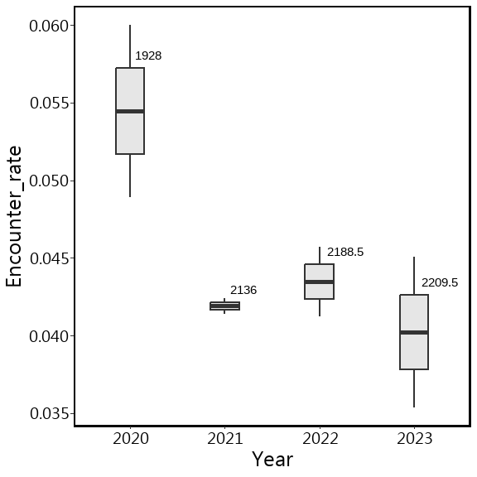

林管處的Encounter_rate

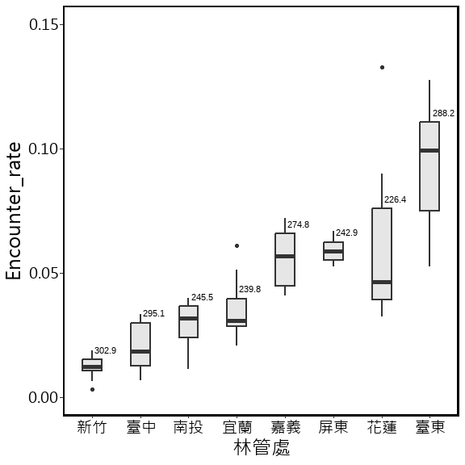

森林類型的Encounter_rate

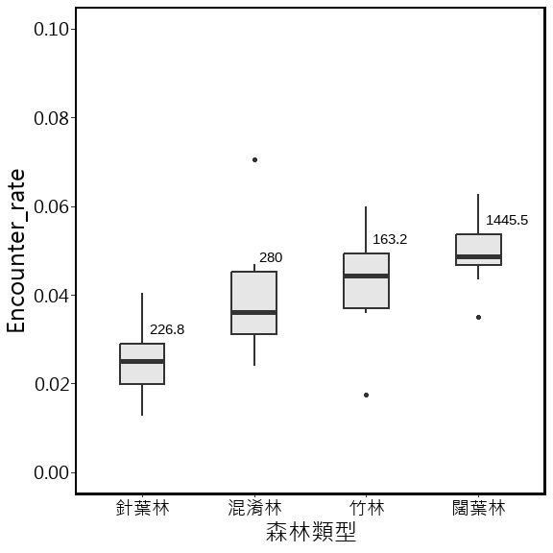

Altitude的Encounter_rate

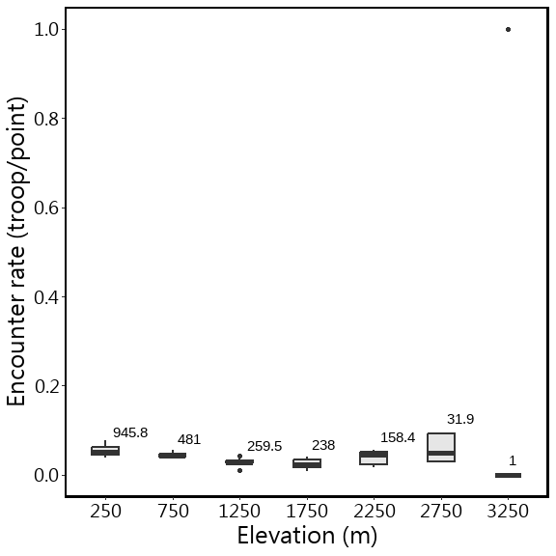

排除3000m以上，再畫一次

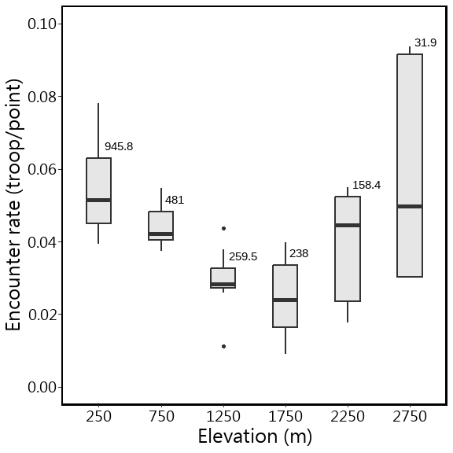

#### 其他補充圖表

非森林的樣點離森林的距離 ( 包含海拔小於50m的樣點)

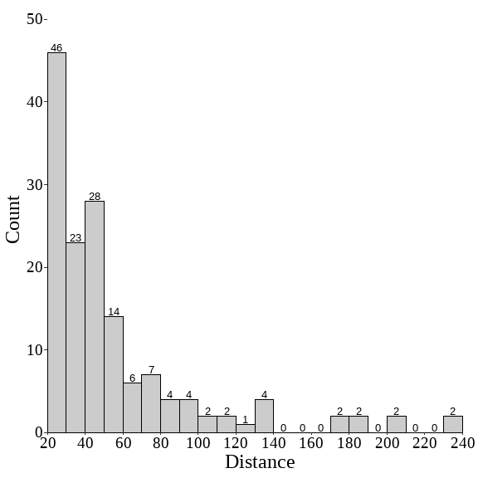

猴群分布的森林類型

| 森林類型 | 森林類型(4th森林圖層) | 樣點數 | 猴群數 |
| --- | --- | --- | --- |
| 混淆林 | 竹針混淆林 | 3 | 0 |
| 混淆林 | 竹針闊混淆林 | 8 | 0 |
| 混淆林 | 竹闊混淆林 | 285 | 23 |
| 混淆林 | 針闊葉樹混淆 | 282 | 0 |
| 竹林 | 竹林 | 339 | 20 |
| 針葉林 | 針葉樹林型 | 474 | 8 |
| 闊葉林 | 闊葉樹林型 | 3,028 | 127 |

猴群分布的海拔 (max Elevation = 2874)

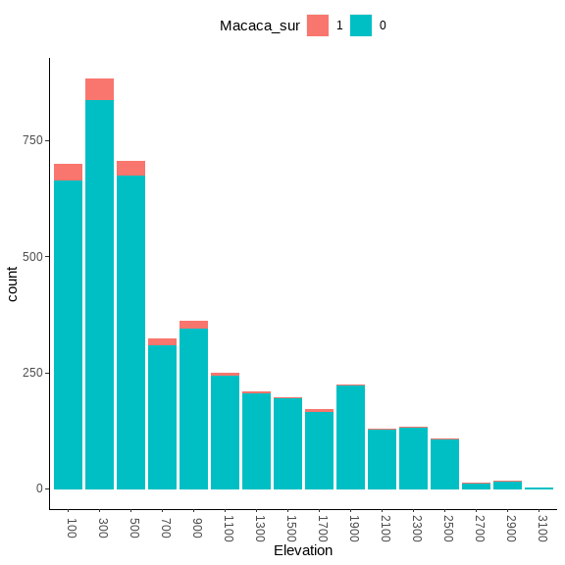

(刪除重複猴群前)大於兩群的樣區列表

|  |  |  |  | 第1旅次 | | | 第2旅次 | | |
| --- | --- | --- | --- | --- | --- | --- | --- | --- | --- |
| Year | Station | 樣區編號 | 樣區名稱 | 調查者 | 刪除前 | 刪除後 | 調查者 | 刪除前 | 刪除後 |
| 2023 | 竹山 | MA-D18-01 | 阿里山61林班 | 周辰蒼 | 3 | 3 |  |  |  |
| 2023 | 觸口 | MA-E22-03 | 隙頂國小草山分校 | 許宏成 | 3 | 2 |  |  |  |
| 2023 | 觸口 | MA-E22-05 | 蘆籐坪 | 許宏成 | 3 | 2 |  |  |  |
| 2023 | 觸口 | MA-E22-07 | 馬頭山路口公車站 |  |  |  | 王日明 | 4 | 2 |
| 2023 | 恆春 | MA-F26-01 | 墾丁苗圃 |  |  |  | 邱水鏡 | 3 | 1 |
| 2023 | 關山 | MA-H33-12 | 寶華 | 周福安 | 3 | 3 |  |  |  |
| 2023 | 成功 | MA-H34-06 | 成功事業區40林班 | 張世華 | 3 | 3 |  |  |  |
| 2023 | 成功 | MA-H34-08 | 成功事業區47林班 | 鄧智文 | 3 | 3 |  |  |  |

單位：群

2023年位在海拔50 m以上森林的調查樣點和臺灣獼猴(Macaca cyclopis)的猴群分布圖。紅色點( )為有猴群的樣點，藍色點( )為沒有猴群紀錄的樣點。

2023年位在海拔50 m以上林管處轄內的調查樣點和臺灣獼猴(Macaca cyclopis)的猴群分布圖。紅色點( )為有猴群的樣點，藍色點( )為沒有猴群紀錄的樣點。

GLMM

Full model:  
m1 <- glmer(猴群數 ~ 年 + 森林類型 + 海拔 + 調查日 + 林管處 + (1|Site_N), family = binomial, data = df)

說明：  
1. 森林類型為類別變數：分別為闊葉林、針葉林、混淆林、竹林等4 種。  
2. 海拔為連續變數，範圍海拔50m以上。  
3. 調查日為連續變數：調查日為當年度的第n天。僅分析3~6月內的調查資料。  
4. 樣區為隨機變數  
5. 分析總筆數：16924 筆；猴群757群。

d1[d1$delta<2,]

## Global model call: glmer(formula = Macaca_sur ~ TypeName.1 + Year.re + Altitude.1 +   
## julian.D.1 + Office + (1 | Site_N), data = df, family = binomial,   
## control = glmerControl(optimizer = "bobyqa"))  
## ---  
## Model selection table   
## (Int) Alt.1 Off Yer.re df logLik AICc delta weight  
## 21 -3.593 + -0.1082 10 -2815.238 5650.5 0.00 0.705  
## 22 -3.612 -0.04519 + -0.1082 11 -2815.107 5652.2 1.74 0.295  
## Models ranked by AICc(x)   
## Random terms (all models):   
## 1 | Site_N

sw(d1)

## Office Year.re Altitude.1 julian.D.1 TypeName.1  
## Sum of weights: 1.00 0.98 0.29 0.27 0.18   
## N containing models: 16 16 16 16 16

sw(model.avg(d1, subset = delta < 2))

## Office Year.re Altitude.1  
## Sum of weights: 1.0 1.0 0.3   
## N containing models: 2 2 1

m1.1 <- glmer(Macaca_sur ~ Year.re + Altitude.1 + julian.D.1 + Office + (1|Site_N),   
 family = binomial, data = df,  
 control = glmerControl(optimizer = "bobyqa"))

## Analysis of Deviance Table (Type II Wald chisquare tests)  
##   
## Response: Macaca_sur  
## Chisq Df Pr(>Chisq)   
## Year.re 9.3078 1 0.002282 **   
## Altitude.1 0.2741 1 0.600563   
## julian.D.1 0.0121 1 0.912306   
## Office 76.0884 7 8.619e-14 ***  
## ---  
## Signif. codes: 0 '***' 0.001 '**' 0.01 '*' 0.05 '.' 0.1 ' ' 1

## Warning in RET$pfunction("adjusted", ...): Completion with error > abseps

| term | contrast | null.value | estimate | std.error | statistic | adj.p.value | signif |
| --- | --- | --- | --- | --- | --- | --- | --- |
| Office | 花蓮 - 宜蘭 | 0 | 0.722 | 0.310 | 2.328 | 0.275 |  |
| Office | 南投 - 宜蘭 | 0 | -0.153 | 0.330 | -0.464 | 1.000 |  |
| Office | 屏東 - 宜蘭 | 0 | 0.614 | 0.306 | 2.005 | 0.475 |  |
| Office | 新竹 - 宜蘭 | 0 | -1.060 | 0.349 | -3.037 | 0.048 | * |
| Office | 嘉義 - 宜蘭 | 0 | 0.372 | 0.312 | 1.190 | 0.934 |  |
| Office | 臺中 - 宜蘭 | 0 | -0.453 | 0.345 | -1.312 | 0.893 |  |
| Office | 臺東 - 宜蘭 | 0 | 1.334 | 0.290 | 4.600 | 0.000 | *** |
| Office | 南投 - 花蓮 | 0 | -0.875 | 0.314 | -2.790 | 0.096 | . |
| Office | 屏東 - 花蓮 | 0 | -0.108 | 0.290 | -0.373 | 1.000 |  |
| Office | 新竹 - 花蓮 | 0 | -1.782 | 0.335 | -5.325 | 0.000 | *** |
| Office | 嘉義 - 花蓮 | 0 | -0.350 | 0.295 | -1.186 | 0.935 |  |
| Office | 臺中 - 花蓮 | 0 | -1.175 | 0.328 | -3.581 | 0.008 | ** |
| Office | 臺東 - 花蓮 | 0 | 0.612 | 0.271 | 2.255 | 0.316 |  |
| Office | 屏東 - 南投 | 0 | 0.767 | 0.314 | 2.444 | 0.217 |  |
| Office | 新竹 - 南投 | 0 | -0.907 | 0.347 | -2.616 | 0.149 |  |
| Office | 嘉義 - 南投 | 0 | 0.525 | 0.307 | 1.711 | 0.677 |  |
| Office | 臺中 - 南投 | 0 | -0.300 | 0.334 | -0.899 | 0.986 |  |
| Office | 臺東 - 南投 | 0 | 1.487 | 0.296 | 5.030 | 0.000 | *** |
| Office | 新竹 - 屏東 | 0 | -1.674 | 0.335 | -5.001 | 0.000 | *** |
| Office | 嘉義 - 屏東 | 0 | -0.242 | 0.298 | -0.813 | 0.992 |  |
| Office | 臺中 - 屏東 | 0 | -1.067 | 0.335 | -3.188 | 0.030 | * |
| Office | 臺東 - 屏東 | 0 | 0.720 | 0.268 | 2.692 | 0.123 |  |
| Office | 嘉義 - 新竹 | 0 | 1.432 | 0.327 | 4.385 | 0.000 | *** |
| Office | 臺中 - 新竹 | 0 | 0.607 | 0.352 | 1.725 | 0.668 |  |
| Office | 臺東 - 新竹 | 0 | 2.394 | 0.319 | 7.509 | 0.000 | *** |
| Office | 臺中 - 嘉義 | 0 | -0.825 | 0.308 | -2.679 | 0.127 |  |
| Office | 臺東 - 嘉義 | 0 | 0.962 | 0.278 | 3.465 | 0.013 | * |
| Office | 臺東 - 臺中 | 0 | 1.787 | 0.314 | 5.699 | 0.000 | *** |

| contrast | null.value | estimate | std.error | statistic | adj.p.value | signif |
| --- | --- | --- | --- | --- | --- | --- |
| Year.re | 0 | -0.108 | 0.035 | -3.051 | 0.007 | ** |
| Altitude.1 | 0 | -0.047 | 0.089 | -0.524 | 0.935 |  |
| julian.D.1 | 0 | 0.005 | 0.043 | 0.110 | 0.999 |  |

glht(m1.1, linfct = c("Year.re = 0",  
 "Altitude.1 = 0",  
 "julian.D.1 = 0")) %>%  
 confint() %>%   
 broom::tidy(.) %>%   
 arrange(estimate) %>%   
 mutate(lhs = factor(contrast, levels=unique(contrast))) %>% # unique() returns values in the order they first appear in the data  
 ggplot(aes(x=lhs, y=estimate)) +  
 geom_hline(yintercept=0, linetype="11", colour="grey60") +  
 geom_segment(aes(xend=lhs, y=conf.low, yend=conf.high), size=0.4,   
 arrow=arrow(ends="both", length=unit(0.05, "inches"), angle=70)) +   
 geom_point() +  
 coord_flip() +  
 labs(x = "", y = "estimate")+  
 theme_classic()

## Warning: Using `size` aesthetic for lines was deprecated in ggplot2 3.4.0.  
## ℹ Please use `linewidth` instead.  
## This warning is displayed once every 8 hours.  
## Call `lifecycle::last_lifecycle_warnings()` to see where this warning was  
## generated.

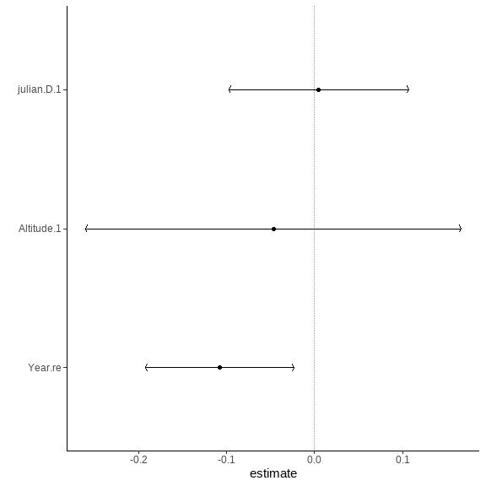

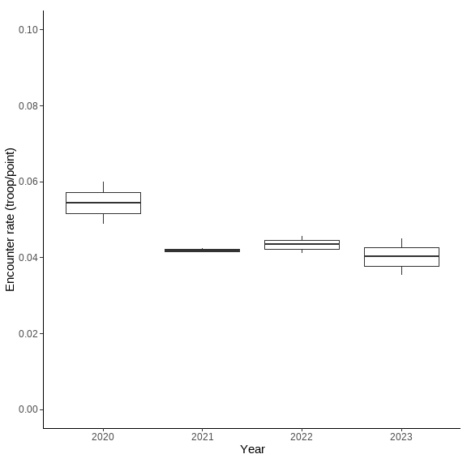

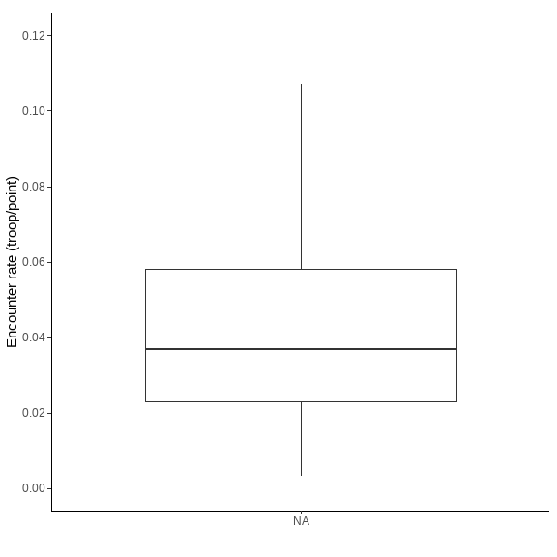

Trim

## Goodness of fit:  
## Chi-square = 1445.77, df=1463, p=0.6207  
## Likelihood Ratio = 1427.90, df=1463, p=0.7395  
## AIC (up to a constant) = -1498.10

wald

Wald test for significance of covariates

## Covariate W df p  
## 1 Region 31.07888 9 0.0002869481

| Covariate | W | df | p |
| --- | --- | --- | --- |
| Region | 31.07888 | 9 | 0.0002869481 |

Wald test for significance of changes in slope

## Wald test for significance of covariates  
## Covariate W df p  
## Region 31.07888 9 0.0002869481  
##   
## Wald test for significance of changes in slope  
## Changepoint Wald_test df p  
## 2020 17.130250 4 0.001823493  
## 2021 4.949492 4 0.292519345  
## 2022 3.219201 4 0.521835274

| Changepoint | Wald_test | df | p |
| --- | --- | --- | --- |
| 2,020 | 17.130250 | 4 | 0.001823493 |
| 2,021 | 4.949492 | 4 | 0.292519345 |
| 2,022 | 3.219201 | 4 | 0.521835274 |

Index  
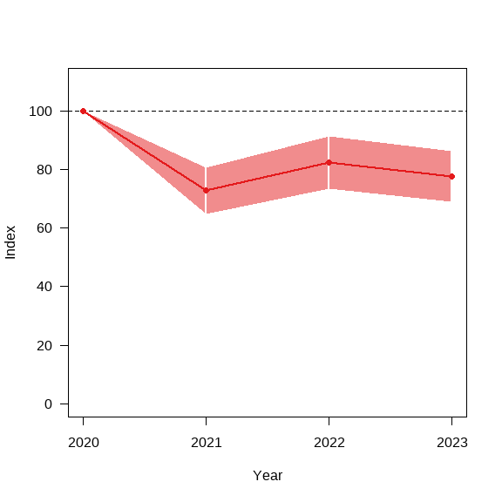

Overall

## from upto add se_add mul se_mul p meaning  
## 2020 2023 -0.06354035 0.03510196 0.9384362 0.03294096 0.2119803 Uncertain

overall

heatmap

index

library(showtext)  
library(ggprism)

## Warning: 套件 'ggprism' 是用 R 版本 4.2.3 來建造的

showtext_auto()  
font_add("Microsoft JhengHei", "msjh.ttc")  
  
theme_bbs <-   
 theme_bw() +  
 theme(  
 plot.background = element_blank(),  
 panel.grid.major = element_blank(),  
 panel.grid.minor = element_blank(),  
 panel.border = element_blank(),  
 axis.title.x = element_blank(),  
 axis.title.y = element_blank(),  
 axis.text.x = element_text(size = 20,angle = 0, hjust = 0.5),  
 text = element_text(size = 30, family = "Microsoft JhengHei"),  
 plot.title = element_text(size = 30, hjust = 0.5),  
 axis.line = element_line(color = "black", size = .1),  
 axis.ticks = element_line(color = "black", size = .1)  
 )

## Warning: The `size` argument of `element_line()` is deprecated as of ggplot2 3.4.0.  
## ℹ Please use the `linewidth` argument instead.  
## This warning is displayed once every 8 hours.  
## Call `lifecycle::last_lifecycle_warnings()` to see where this warning was  
## generated.

idx <- index(m1, "imputed", covars = T) %>%   
 dplyr::select(covariate, category, time, imputed = imputed, se_imp = se_imp)  
  
p <-   
ggplot(idx[idx$covariate %in% "Overall",], aes(x = time, y= imputed*100 ))+  
 geom_hline(yintercept=100, linetype = 2, linewidth = 0.3)+  
 geom_errorbar(  
 aes(x=time,  
 ymax = 100*(imputed + se_imp),  
 ymin = 100*(imputed - se_imp)),  
 width=.03, colour = '#d6ce93', size = .3)+  
 geom_line(data = idx[idx$covariate %in% "Overall",],  
 aes(x = time, y= imputed*100 ),  
 colour = '#d6ce93', linewidth = 0.6, linetype = 1)+  
 geom_point(colour = '#d6ce93', size = 2.5, shape = 21,  
 stroke = 0.6, fill = '#ef4926')+  
   
 # labs(title = fig_title) +  
   
 expand_limits(y = 0) +  
 scale_x_continuous(  
 breaks = c(seq(2020, 2023,1))#,  
 # labels = c(seq(2020, 2022,1))  
 )+  
 scale_y_continuous()+  
 theme_bbs+  
 coord_cartesian(clip = "off") +   
 annotation_ticks(sides = "b", type = "both",size = 0.2,  
 outside = T,  
 tick.length = unit(1, "mm"),  
 minor.length = unit(0.5, "mm"))  
  
 ggsave(filename = paste0("trim_index_MACACA.png"),p, device ="png",  
 path =here("./Report of Foresty_20231026"),  
 width = 5, height = 5, units = "cm",dpi = 300)

Overall.mul <- overall(m1, "imputed")$slope$mul  
Overall.se_mul <- overall(m1, "imputed")$slope$se_mul  
  
round( 100*(Overall.mul-1.96*Overall.se_mul) ,1) #`LCL`

## [1] 87.4

round( 100*(Overall.mul+1.96*Overall.se_mul) ,1) #`UCL`

## [1] 100.3

idx_2023 <- idx[idx$covariate %in% "Overall" & idx$time %in% "2023",]$imputed  
  
round( 100*(idx_2023 -1) ,0) # idx_2022指標變化值

## [1] -22